**16/07/2024 Java Lab Codes**

Program 1:

/* 16-07-2024 */

/*23BAI1354*/

public class Pgm1

{

public static void main(String[] args)

{

    System.out.println("Hello World");

}

}

Output:

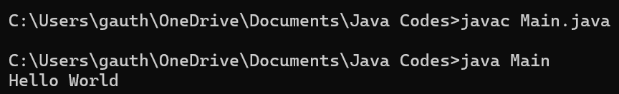

Program 2:

/* 16-07-2024 */

/*23BAI1354*/

public class Main

{

public static void main(String[] args)

{

    String name="John";

    System.out.println(name);

}

}

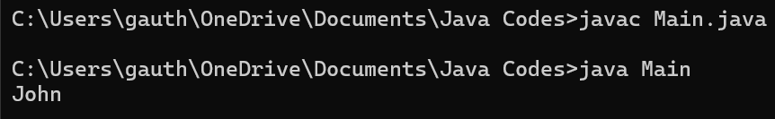

Program 3:

/* 16-07-2024 */

/*23BAI1354*/

public class Main

{

public static void main(String[] args)

{

    int myNum = 15;

    System.out.println(myNum);

}

}

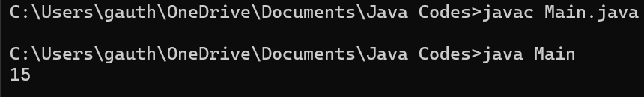

Program 4:

/* 16-07-2024 */

/*23BAI1354*/

public class Main

{

public static void main(String[] args)

{

    int myNum = 15;

    System.out.println(myNum);

    myNum=20;

    System.out.println(myNum);

}

}

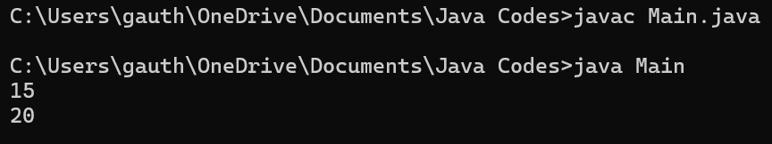

Program 5:

/* 16-07-2024 */

/*23BAI1354*/

public class Main

{

public static void main(String[] args)

{

    final int Num=15;

    System.out.println(Num);

    Num=29; /* error thrown while compiling the file */ /* error: cannot assign a value to final variable Num */

}

}

